The Dynamics of Message Exposure Online in Political Discussion Forums:

Self-Segregation or Diverse Exposure?

Hyunjin Songa & Jaeho Chob

a Department of Communication, University of Vienna, Austria

b Department of Communication, UC Davis, USA

Hyunjin Song

Rathausstraße 19/1/9

Vienna, 1010

Austria

[hyunjin.song@univie.ac.at](mailto:hyunjin.song@univie.ac.at)

Jaeho Cho

375 Kerr Hall

1 Shields Avenue

Davis, CA 95616

USA

[jaecho@ucdavis.edu](mailto:jaecho@ucdavis.edu)

Paper to be submitted to Journal of Communication (OR Political Behavior)

Abstract

While internet spaces are believed to expose individuals to a wider array of viewpoints, a worry about self-reinforcing political echo chambers persists. With unprecedented choices online, do these choices lead to cross-cutting exposure or inevitably lead to increasing polarization? Instead of assessing political homogeneity online solely based on written messages, we focus on individuals’ underlying motives and mechanisms that drives one’s message “reception” decisions, and how such dynamics would manifest through patterns of individuals’ message selection behaviors. Using unobtrusively logged behavioral data matched with panel survey responses, a TERGM analysis of online message selection behaviors during 2012 South Korean Presidential election indicates that the impact of *overt* partisan preference was rather limited. Rather, results indicate that various endogenous structural factors are pronounced, coupled with a non-trivial degree of message selection based on similarity of one’s candidate evaluative criteria, suggesting that social and utility consideration indeed strongly override overt partisan considerations.

*Keyword*: Online political discussion, online discussion forum, message selection and exposure, Temporal exponential random graph model

**The Dynamics of Message Exposure Online in Political Discussion Forums:**

**Self-Segregation or Diverse Exposure?**

Based on the Harbermasian ideal of free and open space for civil society, the internet has long been regarded as *the* pivotal space in which a diverse group of individuals connect each other and voluntarily participate in political processes (Papacharissi, 2004; Stromer-Galley, 2003; Wojcieszak & Mutz, 2009). Internet space is believed to expose individuals to a wider array of viewpoints and perspective, fostering the quality and richness of citizen deliberation (Dahlgren, 2005). Yet this view of internet space as “a free and open space for civil society” (Himelboim, 2011, p. 634) has been increasingly contested by many critics.

While the question of how exactly the internet has changed the landscape of everyday cross-cutting exposure is still an open question to address, online discussion forums in particular afford a situation that is relatively free from contextual constrains (Dahlgren, 2005). In such settings, individuals’ choices regarding which information they choose to encounter and whom they choose to associate are relatively unconstrained. Correspondingly, there has been a growing and widespread worry about self-reinforcing online political echo chambers (e.g., Sunstein, 2009) afforded by digital technologies that help filter out unwanted viewpoints from one’s own (Dylko, 2016). Parallel with the observation that self-selected partisan homogeneity in one’s day-to-day information diet (Iyengar & Hahn, 2009; Stroud, 2011) and in offline social networks (Iyengar & Westwood, 2015) is increasing, a similar speculation of increasing political homogeneity online has been repeatedly raised by many scholars (e.g., Boutyline & Willer, 2017; Colleoni et al., 2014; Sunstein, 2009). With unprecedented choices of what to discuss and whom to interact with within an online setting, do these choices contribute to cross-cutting exposure across ideological divides – as heralded by many students of deliberative theorists – or inevitably lead to increasing polarization driven by a purposive search for political homogeneity as skeptics argue? Yet empirical endeavors to address this question have produced mixed findings at best (e.g., Gentzkow & Shapiro, 2011; Messing & Westwood, 2012), and therefore the exact nature and etiology of partisan homogeneity online (or a lack of thereof) are not yet clearly understood.

In this paper, we attempt to advance our understanding on this debate by focusing on *message selection* dynamics in online discussion forum. Although great progress has been made, much of the prior work on this topic has been primarily based on participants’ retrospective self-reports (Stromer-Galley, 2003; Wojcieszak & Mutz, 2009) or solely based on “observable” posted messages (e.g., Himelboim, 2008; 2011; Graham & Wright, 2014). Recent studies have begun to explore one’s selection behaviors in online social networks, yet those studies are at best based on “channel” selection (e.g., “following” relations in Twitter: Boutyline & Willer, 2017; Colleoni et al., 2014), where such decisions are taken *after* one is exposed to other’s (presumably several) messages. As a consequence, there has been a lack of systematic investigation as to individuals’ *message* *reception* decisions – whether one chooses to *read* a given message in a forum – even before one chooses to react to a given message. This oversight is particularly troubling, since the proper identification of the impact of political preferences on cross-cutting *exposure* online requires not only information between visibly connected dyads (i.e., post – reply relations) but also critically hinges on information between dyads that are traditionally unobservable based on content data (i.e., who choose not to reply despite reading others’ messages). Since typical retrospective self-reports or content-only based examination cannot answer such a question, it precludes a meaningful assessment of impact of underlying factors in producing balanced *exposure*.

Instead of assessing the extent of political homogeneity solely based on written messages, we instead direct our attention to individuals’ underlying motives and mechanisms that drive message *reception* (i.e., reading) decisions. Our goal here is to identify whether, and how, citizen’s free and voluntary interactions – as a form of reading one another’s messages – result from a purposive search for political similarity, or instead propelled by other motivations and structural features of discussion settings, which is largely incidental to one’s overt partisan preferences. In doing so, we also stress how such dynamics would manifest themselves in terms of whose messages are more likely to be “exposed” (i.e., *being read* by others). Understanding this issue has important political ramifications, as it enables us to grasp a more nuanced picture of how aggregate exposure patterns – as an end-result of one’s message selections – *emerge* from individuals’ choice behaviors. Following Song (2015), Lazer et al. (2010) and others, we also acknowledge that such complex dynamics in one’s interaction patterns “cannot be regressed to mere individuals’ predispositions or pure social selection processes based on gender, race, or political viewpoints” (Song, 2015, p. 18). As such, we focus on three different “levels” within which such dynamics would unfold and manifest – individual’s motivations, dyadic homophily, and network structural-level factors.

In what follows, we emphasize two competing explanatory principles – *consistency* and *understanding* – as the two motivational drivers of citizen’s online political interactions. Next, we further advance our perspective on how such competing principles could operate in a dyadic setting, and ultimately, how the structures of online discussion itself could recursively influence individual’s selection decisions. We then offer empirical assessment using novel panel survey data matched with behavioral log data, where we invite participants to an online forum in which their posting and browsing behaviors are unobtrusively logged during a presidential election period. Providing a detailed picture of “who” selects “who’s messages” in an online discussion forum and its correlates during a period of heightened attention to politics (i.e., a presidential campaign), our data are aptly suited for disentangling whether online exposure patterns are primarily structured along the partisan lines. Using an inferential network-analytic method called temporal exponential random graph model (TERGM), our results strongly support the notion that the impact of political preferences in shaping one’s exposure decisions are much more limited than it often assumed.

**Two Motivational Drivers of Political Discussion: *Consistency* and *Understanding***

A recurring theme in the study of mass political behavior is the degree to which the decisions that citizens make regarding which messages they choose to encounter is primarily informed by their political beliefs (e.g., Iyengar & Hahn, 2009; Stroud, 2011) or rather driven by other factors than one’s overt political preferences (e.g., Messing & Westwood, 2012). What underlies these contrasting perspectives is the distinction, broadly conceived, between different psychological motivations based on *cognitive consistency* vs. *understanding* principles (Holbert, Weeks, & Esralew, 2013). Based on the cognitive consistency principle, for instance, balance-theoretic frameworks reveal that individuals disproportionately seek out attitudinally congruent information (e.g., Iyengar & Hahn, 2009; Stroud, 2011). In contrast, the principle of *understanding* posits that people desire to accurately understand and make sense of the world (Holbert et al., 2013). From this angle, it is conceivable that those who have a higher understanding motivation are likely to seek out and to carefully process relevant information, regardless of its potential valence. This is indeed in line with the findings that need for cognition (Cacioppo et al., 1996) or accuracy motivations (Valentino et al., 2009) positively predict a host of information seeking behaviors.

Within the context of the current study, we expect that messages written by those who have higher *consistency* motivations will communicate strong, clear partisan information (Ahn, Huckfeldt, & Ryan, 2014). Based on their added value of its partisan nature, such messages are then disproportionately more likely to be the *target* of others’ message selection behaviors, considering the widespread preferences towards attitudinally congruent information in general public (Garrett & Stroud, 2014). In contrast, those with higher *understanding* motivations (such as those with high need for cognition) are less likely to be expressive of their partisan viewpoints, not least they are prone to make more considerate judgements concerning pros and cons from diverse political perspectives (e.g., Rudolph & Popp, 2007). Since their messages are less likely to contain strong, one-sided partisan information, they are less likely to be a target of message selection behaviors.

While predicting patterns of message selection *received* (i.e., incoming selection) is rather straightforward, it is bit less clear for *out-going* selection patterns, as two explanatory principles offer slightly diverging predictions. That is, many of the prior research predicts that, based on the consistency principle, cognitive dissonance will motivate an aversion to attitudinally incongruent information (Iyengar & Hahn, 2009; Stroud, 2011). Therefore, to the extent that those with higher consistency motivations are *avoiding* incongruent information, they are more likely to “selectively” approach to socially provided messages in fear of encountering information they may disagree (e.g., Shook & Fazio, 2009). This would make them *less* likely to seek out others’ messages in general.

However, a recent advance in this topic begins to suggest that strong partisans (presumably with high consistency motivations) do not necessarily avoid attitudinally incongruent information *at all times* (Garrett & Stroud, 2014; Valentino et al., 2009). These studies point out that avoidance is not the only way of responding to counter-attitudinal information, highlighting the potential role of accuracy (i.e., understanding) motivations (e.g., Valentino et al., 2009) or “social utility” (e.g., Messing & Westwood, 2012) in promoting more balanced exposure. While this view has important normative components, it also implies that approach tendencies toward (potentially) attitudinally incongruent information based on one’s understanding needs will sometimes override, or at least work against towards, an aversion of incongruent information motivated by cognitive consistency.

While two competing perspectives offer diverging predictions, we lack a clear theoretical rationale favoring one over the other. Therefore, we simply ask:

**RQ**: Does accuracy motivation more strongly predict out-going message selection, or does consistency motivation more strongly predict out-going message selection patterns messages in the online discussion forum?

**Principles of Consistency and Understanding at Dyadic Level**

Above and beyond the pure individual-level, the cognitive consistency principle further leads us to hypothesize a positive impact of partisan preference *homophily* in their message selection dynamics. The notion of homophily, or the tendency of a given dyad to associate with each other based on their similarities (McPherson, Smith-Lovin, & Cook, 2001), has long been regarded as a powerful determinant of message exposure decision (Garrett & Stroud, 2014; Iyengar & Hahn, 2009; Song, 2015). Either based on an explicit application of political preferences or based on de facto preference similarity based on other similar characteristics, research has repeatedly suggested the possibility that people can selectively construct their social environment around them (Kossinets & Watts, 2009; Lazer et al., 2010; McPherson et al., 2001). Within the present context, this means that an ego (“focal respondent”) and alters (“potential discussion partner”) are more likely to select each other’s messages if they share similar political preferences. Therefore, we posit that:

**H1**: There would be a more than expected by chance likelihood of message selection based on similar political preference increases in the online discussion forum.

Contrary to the consistency principle, from the perspective of the understanding principle we expect voters are inclined to search for information that has a high “utility.” While arguably such “utility” could be based on many different criteria, reducing an information cost of accurately evaluating candidates and policy options is potentially a viral concern for many voters (Downs, 1957; Pietryka, 2016) especially during a period of heightened political interest. We therefore expect voters of similar candidate evaluation criteria are more likely to select each other’s message, irrespective of their congeniality towards their prior preference. This is based on the expectation that such information is of high utility to make relevant judgments regarding whom they should (or should not) support for. Prior literature agrees while voters actively glean relevant information from their social networks, they also appear to value political expertise more than shared preferences (Ahn et al., 2014). Hart et al.’s (2009) research, for instance, have found that disconfirmation bias is substantially reduced when encountered with messages of higher informational value. Since messages that are similar in terms of judgmental criteria (on which others make candidate evaluations) may contain highly relevant information and signal utilities, voters are more likely than otherwise to select such messages – especially when they are motivated to make accurate evaluations towards political candidate. Formally:

**H2**: There would be a more than expected by chance likelihood of message selection based on similarity in candidate evaluation criteria in the online discussion forum.

**Endogenous Impact of Network Structure**

While aforementioned factors are important aspects of message selection dynamics at its own right, they do not operate in a social “vacuum.” As such, any theoretical perspective that ignoring substantive interdependencies among actors is inevitably incomplete. Below, we attempt to explicate such interdependencies in explaining message exposure patterns.

**Reciprocity**

Often in online discussion forums, users not only intentionally seek for certain information, but they also spontaneously exchange, respond, and react to others’ opinions and messages. This presumably may take a number of possible forms, yet the most simple and frequent form of such “interaction” may manifest as continuous, interactive message exchange sequences among a set of members. This also implies that such interaction patterns may require a situation in which an actor *i* and actor *j* mutually choose to view each other’s messages, direct and return their attentions to each other – provided that leaving a reply or comments necessitate a responder to actually click and read the original message at first place. Based on this expectation, we hypothesize that reciprocity, or the extent of which the relationships between actors in a social network are symmetric (Wasserman & Faust, 1994), would be one of the significant and positive predictors of online message selection:

**H3**: There would be a more than expected by chance likelihood of message selection based on reciprocity in the online discussion forum.

**Transitivity, Cyclic Closure, and Local Hierarchy**

Transitivity and cyclic closure may represent another mechanism of how individuals choose to encounter socially provided messages. The concept of transitivity denotes a situation where node *i* is more likely than chance to create a tie to another node *j* when they are connected to another node *k*. In contrast, cyclic closure denotes similar situation but for node *j* to form a tie to node *i* (Holland & Leinhardt, 1976), as can be seen in Table 1 Below.

While the most common explanation for transitive is that it reflects a local spread of social relations (e.g., “friends of my friends are my friends”), such explanation is somewhat less likely within the context of *message selection* in an online discussion forum. That is, a spread of social relationship requires actors to be aware of each other’s social relationships in choosing one another to interact. However, within online discussion forum settings, information whether or not *k* has chosen to view *j*’s messages (which is a prerequisite of a spread of social relations) is generally not available when *i* choose to view *j*’s messages.

We therefor argue another, yet more plausible, possibility is that transitivity patterns arise from the hierarchical nature of underlying criteria on which people choose each other’s messages. That is, node *i* would seek to create a tie towards a “higher status” node *j* given the exiting relations with intermediate-status node *k*. Coupled with negative tendency towards cyclic closure (e.g., *j* is less likely to form a tie to lower status individual *i*), such pattern can be interpreted as the local status hierarchy in a given network (Lazega et al., 2012). Indeed, people’s political expertise level is not evenly distributed (Delli Carpini & Keeter, 1996), and people routinely rely on and seek guidance from those who are more politically attentive (Downs, 1957; Huckfeldt, 2001; McClurg, 2006). Consequently, one possible source of such hierarchical network structuring principles can be an individual’s need for having political experts around and choose to view messages of those local experts. Therefore, we predict:

**H4**: There would be a more than expected by chance likelihood of message selection based on local hierarchy in the online discussion forum.

**Profile Similarity**

Another important mechanism that help us understand the nature of message selection in online forums is the concept of profile similarity (DiMaggio, 1986). In addition to the hierarchical nature of underlying criteria on which people choose each other’s messages, they may choose to view one another’s message because they both connected to the same way to other actors in the network. For instance, if node *i* and *j* both choose to view same many alters (“activity closure”), or *i* and *j* are *chosen* by same many alters (“popularity closure”: see Table 1 below), then such similar patterns of connections signal the common properties of a given dyads (Block & Grund, 2014; Robins et al., 2009). In such situation, *i* and *j* themselves are more likely to see each other’s messages, and may be viewed as structural bases of homophily, in that the formation of ties is driven by similarity in choices with respect to other actors (DiMaggio, 1986). Therefore:

**H5**: There would be a more than expected by chance likelihood of message selection based on the profile similarity in the online discussion forum.

**Preferential Attachment**

Many studies indicate that a structure of online social network tends to follow a power-law distribution, characterized as the skewed distribution of degrees (Barabási & Albert, 1999; Snijders, 2011). While the existence of such a pattern is rather common, it appears that such tendencies are also pronounced in online context. For instance, Himelboim’s (2008; 2011) analysis suggests a sharp inequality in ability to draw attention and elicit further engagement with a given message from a large number of users in online discussion groups. Within an online discussion forum, one often employs certain heuristic cues such as the number of “views” and “likes” in selecting which messages to click, which signals “utility” based on popularity of a message. Therefore, a message that has large number of engagement cues (such as views or likes) can draw disproportionate selection behaviors by its self-reinforcing dynamics, leading to highly imbalanced distribution of message selection instances. Therefore, we expect:

**H6**: There would be more than expected by chance likelihood of selecting messages when such messages are *already* selected by a large number of others.

**Temporal Dynamics in Message Selection Criteria**

As elections near, it is reasonable to believe that individuals are more mobilized by campaign communication (Cho, 2013), hence are expected to pay close attention to political messages both in online and offline context. Not only a heightened attention to politics in general more likely to make them to do so, but they also may need more information to reduce uncertainties or anxieties regarding their decisions as the election day approaches (Downs, 1957). While literature generally suggests that strong partisans and interested voters arrive their decisions early in the election campaign cycle (Fournier et al., 2004), the nature and extent of changes in campaign environment may prompt them to seek out confirmatory information. Specifically, increases in uncertainty regarding the ultimate consequences of election outcome may propel confirmatory information seeking behavior (Carnahan et al., 2016; Valentino et al., 2009). Literature also suggests if counter-attitudinal information is less useful for reducing decision-related uncertainty and anxiety, then individuals are more expected to rely on confirmatory evidence (Valentino et al., 2009). To the extent that changes in campaign environment (e.g., campaign competitiveness) *over time* induce more anxiety and uncertainty regarding the election outcome, this further suggests that the effect of preference homophily may increase rather than being constant over time. Therefore:

**H7**: The effect of preference homophily in message selection increases over time.

**Data and Methods**

In order to test our predictions, we draw a unique set of panel data collected during the 2012 South Korean presidential election. The data were collected from an online discussion forum hosted on research firm’s server where participants’ posting and viewing activities during 27 day-period until Election day (from November 23 to December 19, 2012) is unobtrusively logged. A market research firm invited 400 participants from a nationally representative panel, of which a total of 341 participants remained on the discussion forum and completed three waves of panel surveys. Surveys measured participants’ candidate evaluations and its criteria, policy preferences, motivations for using the online discussion forum, and other key covariates of interest.[1] Participants were instructed to freely post and read each other’s opinions regarding upcoming election as they normally would in other online forums in return for a monetary incentive of $100 (provided upon the completion of the project). Their activity log regarding posting and browsing behaviors were later retrieved from the research firm’s computer server and matched with participants’ survey responses.

At the start of the wave 1 survey, 22 participants (6.5%) out of all 334 participants did not initially identify their candidate preference nor had favored one of two major candidates based on relative thermometer ratings. Since we control for actors’ candidate choices and preference homophily as a key predictor in our model, we limit the analysis to those with known candidate choices across all three survey waves (*N* = 312). Yet an identical model including 22 missing cases with multiple imputation (*N* = 5) on candidate preference did not substantially alter the results and conclusion reported herein.

**Construction of Networks and Analysis Strategy**

Over the period of data collection, participants on average posted 24.78 messages and read 547.31 postings made by others. Based on activity log of participants’ message browsing behaviors, we derive a “message exposure” network as a directed actor-actor binary matrix (312 x 312), such that the cell entry X*ij* is defined as 1 when actor *i* chooses to view actor *j*’s message and zero for otherwise. As such, we also distinguish the direction of ties in this network (i.e., X*ij ≠* X*ji*). Based on the dates of three panel survey (W1 = Nov 27th to 29th, W2 = Dec 11th to 13th, W3 = Dec 21th to Dec 23th), we partition log data in a way that it closely matches with survey dates in creating longitudinal panel networks of message exposure (e.g., log data from Nov 27th to 29th were regarded as the 1st wave of the network panel).[2] Since the 3rd wave of the survey was conducted *after* the election day (which was Dec 19th) whereas electronic log data were collected *only until* the election day, we regard the last three days of log data (Dec 17th to 19th) as the last panel in network.[3] In addition, since the log data were available from November 23rd, the log data *before* the first wave of panel survey (Nov 27th) or *between* each survey waves were regarded as lagged observation of the respective network panel. Specifically, log data from Nov 23rd to 26th were considered as the lagged observations of the first network (Nov 27th to 29th). Likewise, log data from Nov 30th to Dec 10th constitute lagged observation of the second network (Dec 11th to 13th) while log data from Dec 14th to 16th constitute lagged observation of the last network (Dec 17th to 19th).

**Measures**

**Consistency and Understanding Motivations.** For consistency motivation (Cronbach’s α = .86, *M* = 4.36, *SD* = 1.03), respondents were asked six items (based on a 7-point scale from “Not at all” = 1 to “Very much” = 7) whether they visit online discussion forums (including discussion forums other than current study) primarily “to justify my opinion of the issue” or “to confirm that my opinion on the issue is correct.” Understanding motivation (α = .81, *M* = 5.26, *SD* = .82) was assessed in a similar manner using four-item measure (e.g., “to make an accurate and objective assessment of the issue”, “to understand others’ opinions”, etc.). Since motivations were measured only once at the first wave of the survey, we regard these characteristics as time-invariant covariates in our model.

**Preference homophily and Evaluative Criteria Similarity**. We define political preference homophily (i.e., *consistency* principle) based on two different operationalization: (a) candidate choice, and (b) policy preference homophily. Candidate choice homophily (W1: *M* = .51, *SD* = .49; W2: *M* = .55, *SD* = .49; W3: *M* = .52, *SD* = .49) was defined in a way that a given dyad were regarded as homophilous (coded as “1”) when they shares the same candidate choice.[4] Policy preference homophily (W1: *M* = .40, *SD* = .16; W2: *M* = .38, *SD* = .16; W3: *M* = .39, *SD* = .16, all range = 0 to 1) was operationalized based on respondents’ preferences towards liberal vs. conservative oriented policy options concerning economic regulation and North Korea issues.[5] We derive a Euclidean distance, *d*, of a given dyadic pairs in terms of their dissimilarity of policy preferences, and this were later converted to similarity by taking 1 / (1 + *d*), so a greater value would represent preference “homophily.”

Next, we define candidate evaluation criteria similarity (*M* = .48. *SD* = .15, range = 0 to 1) in a similar manner, 1 / (1 + *d*), using a dyadic Euclidean distance *d* in terms of relative importance of competence/impression (e.g., policy, competence, or perceived personal characters such as integrity) versus personal background (e.g., party affiliation, political career, place of origin, etc.) in candidate evaluations. Since candidate evaluative criteria was measured only at Wave 1 survey, we regard this measure to be invariant across waves.

**Network-Endogenous Measures.** Reciprocity was captured by whether a pair of actors had mutual “selection” ties with each other. For measures tapping a series of triadic configurations (transitive closure, cyclic closure, activity closure, and popularity closure: see Figure 1 for details), we rely on *directed* version of the geometrically weighted edgewise shared partner (directed GWESP) statistics following the model specifications proposed by Snijders et al. (2006) and Robins et al. (2007). The GWESP term models a linear combination of an entire distribution of directed triangles (*i, h, j*) for a given connected dyad (*i, j*) in the network, and this effect is *weighted to produce a decreasing return* following a decay parameter (for a detailed discussion of this measure, see Hunter & Handcock, 2006). As described above, our theory suggests that a series of triadic closure patterns would have a substantial effect on message selection dynamics. Similarly, for measuring in- and out-degree distribution effects, geometrically weighted out-degree and in-degree distribution (GWD-out and GWD-in) terms were used where the parameter estimates for GWD terms represent “evenness” of in- and out-degree based on message selection activities across the network (for details see Hunter, 2007). We expect these terms to be significantly and highly negative, which signify differential message selection activities across the network.

**Control Variables.** In addition to focal predictor variables, we control for a host of variables that are known to be related to the extent of political discussion in order to establish a plausible baseline in our analysis. First, we control for participants’ socio-demographic factors such as *gender* (1 *being* “female,” 48.39%), *age* (in 10-year increment, *M* = 3.55, *SD* = .98), *education* (from “not finished elementary school” = 1 to “currently in post-graduate education or more” = 9, *M* = 7.71, *SD* = .97) and *region of origin* (1 being “Seoul” vs. 0 being “other regions”, 40.38% from Seoul). In our analysis, we also control for two demographic homophily, one based on their gender and the other based on their regional origin (all coded as 1 if a dyad share same gender or regional origin) since preference homophily may be confounded with demographic homophily (McPherson et al., 2000). We also control for respondents’ offline discussion frequency (from “Never” = 1 to “Always” = 7, W1: *M* = 4.50, *SD* = 1.04; W2: *M* = 4.62, *SD* = 1.18; W3: *M* = 4.82, *SD* = 1.17), media use frequency (measured in *hours*, W1: *M* = .76, *SD* = .42; W2: *M* = 1.56, *SD* = 1.66; W3: *M* = 1.65, *SD* = 2.32), internal discussion efficacy (from “Not at all agree” = 1 to “Strongly agree” = 7, *M* = 4.72, *SD* = .98), and hedonic motivation (α = .75, *M* = 4.47, *SD* = 1.04) for using online discussion forum. Media use frequency was defined as the average hour of exposure to internet, newspaper and television news exposure regarding the upcoming election, and internal discussion efficacy were gauged using a four-item composite measure tapping how competent and efficacious an individual is in typical political discussion settings (e.g., “I am competent at presenting my own opinions in a discussion”). Hedonic motivation was assessed by a three-item measure, all anchored on a 7-point scale, asking whether they participate in online forum based on pleasure-seeking motives (e.g., “it is interesting and fun”).

**Analysis Strategy**

Since we aim to properly capture and explain substantive interdependency dynamics over time, we modeled longitudinally observed message selection networks using a Temporal Exponential Random Graph Model (TERGM), a time-series extension of the ERGM framework with bootstrapping resampling technique as described in Desmarais and Cranmer (2012). The integral part of this approach is to model the ties in a given network to be a random variable (“1” for existence of ties, and zero for otherwise) to be explained simultaneously by a collection of actor covariates and network-endogenous dependencies (Robins et al., 2007; Snijders et al., 2006) while properly account for the non-independence of observations inherent in network data. The ERGM framework is now regarded as the most versatile yet flexible method for evaluating underlying generative properties of a network, as exemplified in recent applications of the method to various domains (Cranmer et al., 2017).

Since our analytical strategy requires all cell entries are defined as binary rather than integers, we opted for dichotomizing numbers of selection instances within a same dyad using a threshold value (W1 = 2.5; W2 = 2.9; W3 = 3.1), which were based on mean number of message selection instances across all dyadic pairs. Therefore, our model only speaks to relatively routine, repeated message selection dynamics in a given network panel rather than entire message selection dynamics including accidental, spontaneous selection behaviors. Also, in applying a longitudinal inferential network analysis technique, we also regard an observation at a given time point is dependent only upon the previous state of the network (i.e. lagged observation). In capturing temporal dependencies, we include series of lagged endogenous network statistics which might be relevant in messages selection behaviors as additional control variables, along with few additional endogenous network statistics (such as *isolates* and *two-paths*) in order to control temporal or lower-order effects in estimating the effect of key parameters. Details on the applied models are provided in the Figure 1 and in online Supplemental Information. Table 1 below summarize key model terms and corresponding hypothesis, with their graphical depiction and substantive interpretation.

[Table 1 About Here]

Once models were fitted, we assessed goodness-of-fit (*gof*) to identify the model adequacy by simulating nine hundred new networks (three hundred new networks for each time step) and compare the network characteristics from the observed vs. simulated networks (Hunter, Goodreau, & Handcock, 2008). The *gof* results indicate that model specification is satisfactory (see online Supplemental Information for details). All analyses were based on maximum pseudo-likelihood estimation with bootstrapped confidence intervals (Desmarais & Cranmer, 2012), as implemented in the *btergm* package in R (Leifeld et al., 2017).

**Results**

Table 2 below reports the parameter estimates from the final TERGM specifications along with its 95% confidence intervals (bias-corrected and accelerated CIs using 1000 replications), and this is also graphically reported in Figure 1 below (full results are available in online Supplemental Information). Relevant to our main interest, the leftmost model specification (“Final Model” in Table 2) includes the effects of motivation and homophily while properly controlling for hypothesized network structural influence, while a series of interaction models from 2nd to 4th columns test whether the effects of various preference homophily increases over time. Across all models, coefficients can be interpreted as log odds of a tie conditional on the rest of the network and other model terms.

[ Table 2, Figure 1 and 2 About Here]

Our research question asked how consistency and understanding motivations systematically affect the likelihood of messages *being selected* by other participants, as well as an individual’s selection patterns (i.e., selecting others’ messages) within the online discussion forum. For the final model specification, we found the effect of consistency motivation being nonsignificant in predicting outgoing selection instances (*b* = .025, 95% bootstrap CI = [−.044, .077]), so as to understanding motivations predicting incoming selection (*b* = −.052, [−.080, .022]). In contrast, we found a weak but significant tendency for consistency motivation predicting in-ties (*b* = .034, [.009, .113]) and understanding motivation predicting out-going ties (*b* = .028, [.005, .076]). Empirical patterns indicate that those who pursue to better understand the outside world are more likely to select and read others’ messages in online discussion forums (compared to those who are low on understanding motivations), while on average people are more likely to select and read messages written by those with higher consistency motivation.

Concerning our dyadic-level homophily variables, neither candidate choice homophily (*b* = −.032, [−.070, .047]) nor policy preference homophily (*b* = −.108, [−.212, .006]) found to be related to the message selection instances, fail to confirm H1. Such null effects of two preference homophily terms indicate that consistency-driven dynamics (i.e., whether one shares same candidate preference or ideological policy preference) is not likely to be related to whether people choose to select and view each other’s messages. Instead, we have found consistent and quite substantial effect of candidate evaluative criteria similarity, such that the more similar a dyad in terms of their candidate evaluative criteria, the more they likely are to expose themselves to another’s messages (H2: *b* = .407, [.399, .415]). We return to the implications of this finding in the discussion section.

Our next set of hypotheses concerns endogenous structural effects of network itself. As shown in Table 2, we have found consistent and robust support for these predictions, such that reciprocity (H3: *b* = .768, [.560, 1.068]), multiple cyclic closure (H4: *b* = −.066, [−.076, −.061]), multiple activity (*b* = .035, [.033, .043]) and multiple popularity closure (*b* = .113, [.083, .232], all H5), and preferential attachment (*Popularity spread*, H6: *b* = −4.123, [−5.343, −3.541]) were all strongly supported, controlling for the tendency for not having any ties (*isolates*: *b* = 1.003), open triad without closing a triad (*multiple two-path*: *b* = .003, all CIs straddle zero), temporal dependencies, and other motivation and homophily terms.

Among estimated effects, notably the effect of preferential attachment (or an uneven degree distribution) was the strongest and substantial, as the negative incoming degree distribution parameter indicates (H6: *b* = −4.123). Figure 2 gives a substantive interpretation of the effect, such that predicted probabilities of receiving at least one additional message selection instance from other participants in the forum (excluding who are already connected) sharply increases as a function of existing in-degree of a node, irrespective of time periods. This suggests that messages selection behaviors are largely driven by self-organizing dynamics, consistent with the notion that people are disproportionately drawn upon and more likely to expose themselves to *already popular* messages in a forum (Himelboim, 2008).

In addition to the effect of preferential attachment, participants in the online forum are approximately 2 times (conditional odds ratio = 2.15) more likely to browse others’ messages based on a reciprocity effect. Likewise, an individual (ego) is approximately 4 to 12 percent more likely to read another participant’s (alter) message for every one person increase in number of other participants that ego and alter are both tied to, based on both outgoing (*multiple activity closure*: conditional OR = 1.035) and incoming connection patterns (*multiple popularity closure*: conditional OR = 1.121). This suggests that when message selection patterns signal latent shared characteristics between a dyad, they are more likely to select each other’s message. Participants in our online forum were also slightly less likely to form a closed three-cycle, suggesting the network has a slight tendency against generalized exchange that returns to a lower status individuals. The only exception for this pattern was the multiple path closure term (concerning H4: *b* = .057, [−.053, .094]), although the direction of the effect was again in the expected direction.

Our last hypotheses predicted that as the election approaches, the impact of preference homophily in predicting message selection dynamics would be increased. Among tested interaction terms, only candidate choice homophily is found to significantly interact with time trends (Interaction model I: *b*interaction = .051, [.038, .071]). Specifically, the effect of candidate choice homophily is found to be linearly increasing over time, in a way that message selection among a dyad that share the same candidate choice is more likely later in the election period, as plotted in Figure 3. Panel B of the Figure 3 gives Johnson-Neyman regions of significance as a function of time trends, additionally revealing that there is indeed a preference *towards heterophily* earlier in the election (as indicated in negative conditional main effect: *b* = −.135, [−.211, −.111]). But this effect gradually disappears as the preference towards same candidate choice increases. No other interaction terms emerged as significant.

[ Figure 3 About Here]

**Discussion and Conclusion**

While prior literature has emphasized the deliberative potentials of online discussions (Papacharissi, 2004; Stromer-Galley, 2003), a worry about self-reinforcing political echo chambers is not uncommon to find in extant literature. While the debate whether or not online settings would promote more diverse and balanced exposure to political information is far from being resolved (Dylko, 2016; Garrett, 2009), a more comprehensive understanding of the underlying motivational and structural factors that drive citizen’s everyday discussion with fellow citizens is extremely important, let alone political conversation does serve as an important motivation for further information seeking and participatory behaviors (McClurg, 2006). Against this background, we emphasized *consistency* and *understanding* as the two core explanatory principles of political discussion online at individual- and dyadic-levels, as well as highlighted the role of various endogenous structural factors that stem from the pattern of online discussion itself as the crucial determinants of message selection dynamics. This contribution is among the first to provide a more direct evidence disentangling various determinants of message *exposure* decisions in an online discussion forum setting. Our findings suggest that while there is some modest tendency based on *both* consistency and understanding motivations (especially at the individual level), the impact of *overt* partisan preference, as measured by candidate choice homophily and policy preference homophily, was fairly limited. Rather, we have observed robust and consistent effects of endogenous structural factors, coupled with a non-trivial degree of message selection based on similarity of one’s candidate evaluative criteria. This yields significant new insights and add important nuance to our understandings as to how people choose to expose themselves to what contents in online discussion settings.

In particular, we have found that those with higher understanding motivation to be active in seeking out and expose themselves to messages provided by others. At the same time, those on high consistency motivations are more likely to be the *target* of such message selection dynamics (i.e., their messages are more likely to be selected by others). In contrast, it was not necessarily the case that those with higher consistency motivations are more likely to seek out – presumably confirmatory – social information. If it had been significant, it would have indicated that those with higher consistency motivations are presumably seeking out and are sought by mostly like-minded individuals, providing a support for the notion (albeit indirectly) that online settings primarily promote strong selective exposure tendencies. However, our results seem to be more in line with Garrett (2009; also see Garrett et al., 2013) or Bakshy et al. (2015), where more balanced exposure is common than it often assumed. While our results also show that a preference towards opinion-reinforcing information (as shown in significant effect of consistency motivation predicting *incoming* ties) is real, yet this does not necessarily being associated with people *only* seeking out confirmatory information.

Perhaps a more direct evidence supporting this perspective comes from our results of three dyadic-level effects. That is, overt partisan homophily – either based on more concreate candidate choice or based on abstract policy preferences – does not play a substantive role in message selection dynamics. Although we have found that the impact of candidate choice homophily had linearly increased over time, the magnitude of such effect was still limited throughout the course of the election period. Instead, we observed that the effect of similarity in candidate evaluation criteria – in other word, a judgmental standard on which other citizens make attitudinal evaluations regarding candidates – was substantial throughout all of the models. It is particularly noteworthy finding given that such similarities in terms of the *judgmental* *standards* do not necessarily warrant attitude similarity, but rather may lead to exposure to different opinions.[6] Consistent with the understanding line of arguments, it suggests that a utility consideration – in other words, specific information they can make use of in candidate evaluations *irrespective of its potential valence* – is one of the crucial factors that determine message selections. Therefore, our results strongly challenge the prevalent notion that, in online settings, people are disproportionately drawn by like-minded others or by confirmatory evidences *at the expense of* avoiding counter-attitudinal information.

Across our analyses, preferential attachment emerged as the strongest predictor of messages selection dynamics, corroborating the recent evidence concerning online (Himelboim, 2008; 2011) and offline political discussion (Song, 2015). While such a pattern is commonly expected in a large-scale network (Barabási & Albert, 1999), it is interesting to find a similar pattern in a network with a fairly modest size of participants. Also, compared to studies concerning readily “visible” interactions such as post-reply relations (Himelboim, 2008; 2011), our behavioral log data concerns a relation of which one’s selection behaviors are not necessarily visible to other participants. This suggests that this global-level message selection dynamic is likely to be, at least partly, driven by aggregate popularity cues (such as number of “views’ or “likes”) that enable participants to identify messages of higher social and informational utilities. At the same time, such aggregate popularity cue per se does not imply that a given message contains congenial information to an individual who selects such message. Considering the fact that the magnitude of this preferential attachment effect far surpasses any of the homophily factors – almost ten times more – in our model, we interpret this pattern as the indication that social and utility consideration indeed strongly override overt partisan considerations, echoing a recent finding of Messing and Westwood (2014) regarding selective exposure dynamics on social networking site context.

While our findings regarding some of the structural factors are quite intuitive, other results, especially a series of triadic configurations, warrant further discussion. Notably, we found significant and positive yet weak “shared activity” and “shared popularity” effects. The pattern suggests that a pair of people who viewed the same set of individuals’ messages, or whose messages are being seen by the same set of individuals, are also likely to see each other’s messages. Within triadic settings such as these, it should be acknowledged that cues indicating similarities of message selection patterns between a specific given dyad are not available, unless the relations being studied are also already visible to participants (such as in message – reply relations) so they could infer such similarities for themselves. Therefore, our settings – which models “low visibility” message selection behaviors – make particularly unlike that these effects are driven by characteristics other than actual similarities in criteria of which participants make choice behaviors.[7] At the same time, unlike our dyadic homophily factors, an extent of similarities in *profiles* (i.e., message selection patterns) enable multitudes of nodal attributes to be simultaneously involved in consideration of such “similarities.” This brings interesting possibility in that people may choose to associate with and engage each other not based on just a single characteristic (such as candidate preference) but some balance (or a sum) of multiple characteristics (“multidimensional homophily”: Block & Grund, 2014). However, the substantive magnitude of such effects appears to be still limited as to other “understanding” driven factors such as evaluative criteria or preferential attachment.

In consideration of this study’s findings, we conclude with few caveats. First, we did not find expected transitive closure effect although the coefficient was in the expected direction. While we do not have any definitive explanation for this unexpected finding, it may be the case that local-level, hierarchy-based dynamics became nonsignificant when there is a strong influence of global-level hierarchies (i.e. preferential attachment – again, almost ten-fold increase in its impact). In ERGM, both triadic closure and degree distributions leads to local clustering while they tend to be highly correlated (Levy et al., 2015).

Second, following our theoretical focus, this study has operationalized “links” among participants as directed message “reading” behaviors. While this is an important addition to the existing literature that tend to focus only on written messages (e.g., Himelboim, 2008; 2011), it leaves many questions unanswered, let alone we did not considered actual message characteristics in our model. Indeed, it is conceivable that individual’s message selection behaviors were at least partly driven by some textual cues available in thread titles (as the first textual cue that respondents would encounter in selecting other’s messages), or by some other interaction effects between network dynamics identified here and message characteristics. While it is arguably an important issue that would add more nuance to our results, it requires to consider how latent textual topics and observed message quantities are probabilistically generated, and how such factors would further condition the observed network dynamics in a stochastic fashion. To our knowledge, a proper probabilistic model addressing such issues is only recently begin to be developed (e.g., Kim et al., 2017).

Third, regarding our interaction effect between candidate choice homophily and time trends, we also acknowledge that such patterns may have been driven by participants’ “learning effects” than campaign competitiveness effect. That is, based on their continued interactions in the forum, they could have acquired implicit knowledge of others’ partisan orientations, which makes them better able to discern partisan leanings of socially provided messages over time. While our empirical pattern is indeed consistent with this alternative explanation, it should be also noted that, ultimately, the impact of candidate choice homophily never exceeded that of other understanding-based effects. As such, the balance of evidence points to the consistent picture that individuals’ message exposure patterns are not necessarily self-segregated along the overt partisan lines.

Lastly, we close by also recognizing that our single-country, single election data approach may not necessarily generalizable to other contexts. Yet, we have observed fairly similar results as to other studies concerning online (Himelboim, 2008; 2011) and offline political discussions (Song, 2015) from considerably a different geographical and electoral context, while a recent controlled experiment also suggests similar empirical patterns (e.g., Pietryka, 2016). While the generalizability of our findings critically dependent upon future replications, we see little reason to expect that basic underlying mechanisms identified in this study would not be equally applicable across different time and context.

In this study, we began by highlighting that online settings do not necessarily create more polarized exposure patterns, but different motivational principles – *consistency* vs. *understanding* – can play a distinctive role in structuring one’s message exposure patterns. Consistent with previous evidence (Bakshy et al., 2015; Garrett & Stroud, 2014; Messing & Westwood, 2014), in online settings individuals do not appear consciously organizing their patterns of everyday political interactions solely based on overt partisan considerations. Our analysis also highlights that endogenous structures of an online discussion network can have a powerful potential for “accidental exposure” across lines of political differences, echoing recent evidence suggested by Lazer et al. (2010) or by Song (2015). While the possibility of individuals being isolated from exposure to different perspectives is still probable online, it seems that it is not an unavoidable consequence of individual’s conscious choices.

Reference

Ahn, T. K., Huckfeldt, R., & Ryan, J. B. (2014). *Experts, activists, and interdependent citizens: Are electorates self-educating?* New York: Cambridge University Press.

Bakshy, E., Messing, S., & Adamic, L. A. (2015). Exposure to ideologically diverse news and opinion on Facebook. *Science*, *348*(6239), 1130-1132.

Barabási, A. L., & Albert, R. (1999). Emergence of scaling in random networks. *Science, 286*(5439), 509-512.

Block, P., & Grund, T. (2014). Multidimensional homophily in friendship networks. *Network Science, 2*(2), 189–212.

Boutyline, A., & Willer, R. (2017). The social structure of political echo chambers: Variation in ideological homophily in online networks. *Political Psychology, 38*, 551-569.

Cacioppo, J. T., Petty, R. E., Feinstein, J. A., & Jarvis, W. B. G. (1996). Dispositional differences in cognitive motivation: The life and times of individuals varying in need for cognition. *Psychological Bulletin*, *119*(2), 197.

Carnahan, D., Garrett, R. K., & Lynch, E. K. (2016). Candidate vulnerability and exposure to counterattitudinal information: Evidence from two US presidential elections. *Human Communication Research*, *42*(4), 577-598.

Carpenter, D. P., Esterling, K. M., & Lazer, D. M. (2004). Friends, brokers, and transitivity: Who informs whom in Washington politics? *Journal of Politics, 66*(1), 224-246.

Cho, J. (2013). Campaign tone, political affect, and communicative engagement. *Journal of Communication, 63*(6), 1130-1152.

Cranmer, S. J., Leifeld, P., McClurg, S. D., & Rolfe, M. (2017). Navigating the range of statistical tools for inferential network analysis. *American Journal of Political Science*, *61*(1), 237-251.

Dahlgren, P. (2005). The Internet, public spheres, and political communication: Dispersion and deliberation. *Political Communication, 22*, 147-162.

Delli Carpini, M. X., & Keeter, S. (1996). *What Americans know about politics and why it matters*. New Haven, CT: Yale University Press.

Desmarais, B. A., & Cranmer, S. J. (2012). Statistical mechanics of networks: Estimation and uncertainty. *Physica A*, *391*(4), 1865-1876.

DiMaggio, P. (1986). Structural analysis of organizational fields: A blockmodel approach. *Research in Organizational Behavior, 8*, 335-370.

Downs, A. (1957). *An economic theory of democracy*. New York: Harper.

Dylko, I. B. (2016). How technology encourages political selective exposure. *Communication Theory*, *26*(4), 389-409.

Fournier, P., Nadeau, R., Blais, A., Gidengil, E., & Nevitte, N. (2004). Time-of-voting decision and susceptibility to campaign effects. *Electoral Studies, 23*(4), 661-681.

Garrett, R. K. (2009). Politically motivated reinforcement seeking: Reframing the selective exposure debate. *Journal of Communication*, *59*(4), 676-699.

Garrett, R. K., & Stroud, N. J. (2014). Partisan paths to exposure diversity: Differences in pro‐and counterattitudinal news consumption. *Journal of Communication*, *64*, 680-701.

Gentzkow, M., Shapiro, J. M. (2011). Ideological segregation online and offline. *The Quarterly Journal of Economics, 126*(4), 1799-1839.

Graham, T., & Wright, S. (2014). Discursive equality and everyday talk online: The impact of “superparticipants”. *Journal of Computer‐Mediated Communication*, *19*(3), 625-642.

Hart, W., Albarracín, D., Eagly, A. H., Brechan, I., Lindberg, M. J., & Merrill, L. (2009). Feeling validated versus being correct: a meta-analysis of selective exposure to information. *Psychological Bulletin, 135*(4), 555-588.

Himelboim, I. (2008). Reply distribution in online discussions: A comparative network analysis of political and health newsgroups. *Journal of Computer‐Mediated Communication, 14*(1), 156-177.

Himelboim, I. (2011). Civil society and online political discourse: The network structure of unrestricted discussions. *Communication Research, 38*(5), 634-659.

Holbert, R. L., Weeks, B. E., & Esralew, S. (2013). Approaching the 2012 U.S. Presidential election from a diversity of explanatory principles: Understanding, Consistency, and Hedonism. *American Behavioral Scientist, 57*(12), 1663-1687.

Holland, P. W., & Leinhardt, S. (1976). Local structure in social networks. *Sociological Methodology, 7*, 1-45.

Huckfeldt, R. (2001). The social communication of political expertise. *American Journal of Political Science*, 425-438.

Hunter, D. R., & Handcock, M. S. (2006). Inference in curved exponential family models for networks. *Journal of Computational and Graphical Statistics*, *15*(3), 565-583.

Iyengar, S., & Hahn, K. S. (2009). Red media, blue media: Evidence of ideological selectivity in media use. *Journal of Communication*, *59*(1), 19-39.

Iyengar, S., & Westwood, S. J. (2015). Fear and loathing across party lines: New evidence on group polarization. *American Journal of Political Science, 59*(3), 690-707.

Kim, B., Schein, A., Desmarais, B. A., & Wallach, H. (2017). *A network model for dynamic textaul communications with appliation to government email corpora*. Paper presented at the 10th Political Networks Conference, The Ohio State University, Columbus, OH.

Kossinets, G., & Watts, D. J. (2009). Origins of homophily in an evolving social network. *American Journal of Sociology*, *115*(2), 405-450.

Lazega, E., Mounier, L., Snijders, T., & Tubaro, P. (2012). Norms, status and the dynamics of advice networks: A case study. *Social Networks, 34*(3), 323-332.

Lazer, D., Rubineau, B, Chetkovich, C., Katz, N., & Neblo, M. (2010). The coevolution of networks and political attitudes. *Political Communication, 27*(3), 248–274.

Leifeld, P., Cranmer, S. J., & Desmarais, B. A. (2017). *btergm*. Temporal Exponential Random Graph Models by Bootstrapped Pseudolikelihood. R package version 1.9.0.

Levy, M., Lubell, M., Leifeld, P., & Cranmer, S. (2016). *Interpretation of geometrically weighted degree estimates in exponential random graph models*. Paper presented at the 9th Political Networks Conference, Washington University, Saint Louis, MO.

McClurg, S. D. (2006). The electoral relevance of political talk: Examining disagreement and expertise effects in social networks on political participation. *American Journal of Political Science*, *50*(3), 737-754.

McPherson, M., Smith-Lovin, L., & Cook, J. M. (2001). Birds of a feather: Homophily in social networks. *Annual Review of Sociology*, *27*(1), 415-444.

Messing, S., & Westwood, S. J. (2014). Selective exposure in the age of social media: Endorsements trump partisan source affiliation when selecting news online. *Communication Research*, *41*(8), 1042-1063.

Papacharissi, Z. (2004). Democracy online: Civility, politeness, and the democratic potential of online political discussion groups. *New Media & Society*, *6*(2), 259-283.

Pietryka, M. T. (2016). Accuracy motivations, predispositions, and social information in political discussion networks. *Political Psychology, 37*, 367-386.

Robins, G., Pattison, P., & Wang, P. (2009). Closure, connectivity and degree distributions: Exponential random graph (*p*\*) models for directed social networks. *Social Networks, 31*(2), 105-117.

Robins, G., Pattison, P., Kalish, Y., & Lusher, D. (2007). An introduction to exponential random graph (*p*\*) models for social networks. *Social Networks, 29*, 173–191.

Rudolph, T. J., & Popp, E. (2007). An information processing theory of ambivalence. *Political Psychology, 28*(5), 563-585.

Shook, N. J., & Fazio, R. H. (2009). Political ideology, exploration of novel stimuli, and attitude formation. *Journal of Experimental Social Psychology, 45*(4), 995-998.

Snijders, T. A. (2011). Statistical models for social networks. *Annual Review of Sociology*, *37*, 131-153.

Snijders, T. A., Pattison, P. E., Robins, G. L., & Handcock, M. S. (2006). New specifications for exponential random graph models. *Sociological Methodology, 36*(1), 99-153.

Song, H. (2015). Uncovering the structural underpinnings of political discussion networks: Evidence from an exponential random graph model. *Journal of Communication, 65*(1), 146-169.

Stromer‐Galley, J. (2003). Diversity of political conversation on the Internet: Users' perspectives. *Journal of Computer‐Mediated Communication*, *8*(3). 0-0.

Stroud, N. J. (2011). *Niche news: The politics of news choice.* Oxford University Press.

Sunstein, C. R. (2009). *Republic.com 2.0*. Princeton University Press.

Valentino, N. A., Banks, A. J., Hutchings, V. L., & Davis, A. K. (2009). Selective exposure in the Internet age: The interaction between anxiety and information utility. *Political Psychology*, *30*(4), 591-613.

Wasserman, S., & Faust, K. (1994). *Social network analysis*. Boston, MA: Cambridge University Press.

Wojcieszak, M. E., & Mutz, D. C. (2009). Online groups and political discourse: Do online discussion spaces facilitate exposure to political disagreement? *Journal of Communication*, *59*, 40-56.

Table 1. Key TERGM parameters, associated configurations, and their interpretations

|  |  |  |
| --- | --- | --- |
| Hypothesis and Parameters | Configuration | Interpretation |
| RQ: Motivation  (consistency vs. understanding) |  | A select B’s message (B’s message is selected by A) based on nodal attributes |
| H1 & H2:  Homophily |  | A and B select each other’s message based on their shared characteristics |
| H3: Reciprocity |  | A select B’s message  when B also select A’s message |
| H4: Multiple  path closure  (GWESP-OTP) |  | A select B’s message when A has multiple intermediary actors that also leads to B  (implies status differentials) |
| H4: Multiple  cyclic closure (GWESP-ITP) |  | A select B’s message when B has multiple intermediary actors that also leads to A  (implies lack of status differential) |
| H5: Multiple  activity closure (GWESP-OSP) |  | A select B’s message when they have similar patterns of message selection patterns  (implies similarity in latent attributes) |
| H5: Multiple  popularity closure (GWESP-ISP) |  | A select B’s message when their messages are similarly selected by others  (implies similarity in latent attributes) |
| H6: Preferential attachment  (GWD-in)* |  | A select B’s message when many others also selected B’s message |

* Preferential attachment is measured using geometrically weighted in-degree distribution statistics, which measures *unevenness* of in-degree distribution. Therefore, *negative* GWD-in statistic means *positive* preferential attachment pattern (Levy et al., 2015).

|  |  |  |  |  |  |
| --- | --- | --- | --- | --- | --- |
|  | **Final Model** | **Interaction I** | **Interaction II** | **Interaction III** | |
| Edges (Intercept) | **-1.890** [-2.932; -1.392]* | **-1.819** [-2.732; -.304]* | **-1.823** [-2.807; -1.169]* | **-1.936** [-2.937; -1.098]* | |
| ***Motivation and homophily*** |  |  |  |  | |
| Consistency motivation (in-ties) (RQ) | **.034** [.009; .113]* | .037 [-.004; .113] | **.037** [.010; .113]* | **.037** [.010; .113]* | |
| Consistency motivation (out-ties) (RQ) | .025 [-.044; .077] | .019 [-.112; .071] | .019 [-.112; .071] | .019 [-.043; .071] | |
| Understanding motivation (in-ties) (RQ) | -.052 [-.080; .022] | -.049 [-.103; .022] | -.049 [-.103; .022] | -.049 [-.078; .022] | |
| Understanding motivation (out-ties) (RQ) | **.028** [.005; .076]* | **.036** [.012; .075]* | **.035** [.011; .087]* | **.035** [.011; .075]* | |
| Hedonic motivation (in-ties) | -.012 [-.029; .001] | -.012 [-.038; .001] | -.013 [-.032; .001] | -.013 [-.038; .001] | |
| Hedonic motivation (out-ties) | **.102** [.087; .133]* | **.102** [.094; .130]* | **.102** [.096; .130]* | **.102** [.094; .105]* | |
| Same candidate preference (H1) | -.032 [-.070; .047] | **-.135** [-.211; -.111]* | -.033 [-.079; .047] | -.032 [-.079; .047] | |
| Similar policy preference (H1) | -.108 [-.212; .006] | -.091 [-.225; .042] | -.090 [-.230; .042] | .094 [-.764; .272] | |
| Similar evaluative criteria (H2) | **.407** [.399; .415]* | **.385** [.260; .404]* | .295 [-.359; .639] | **.389** [.255; .405]* | |
| ***Interaction (H7)*** |  |  |  |  | |
| Time trends (linear) |  | .079 [-.059; .262] | **.083** [.021; .171]* | **.144** [.063; .235]* | |
| x Same candidate preference |  | **.051** [.038; .071]* |  |  | |
| x Similar evaluative criteria |  |  | .046 [-.176; .242] |  | |
| x Similar policy preference |  |  |  | -.095 [-.253; .214] | |
| ***Endogenous structural effects*** |  |  |  |  | |
| Isolates | **1.003** [.793; 1.264]* | **1.005** [.793; 1.152]* | **1.005** [.895; 1.264]* | **1.003** [.793; 1.264]* | |
| Reciprocity (H3) | **.768** [.560; 1.068]* | **.768** [.559; 1.068]* | **.768** [.507; 1.068]* | **.768** [.560; 1.068]* | |
| Multiple path closure (H4) | .057 [-.053; .094] | .057 [-.053; .125] | **.057** [.025; .125]* | .057 [-.053; .094] | |
| Multiple cyclic closure (H4) | **-.066** [-.076; -.061]* | **-.066** [-.076; -.061]* | **-.066** [-.080; -.061]* | **-.066** [-.076; -.061]* | |
| Multiple activity closure (H5) | **.035** [.033; .043]* | **.035** [.033; .041]* | **.035** [.033; .043]* | **.035** [.033; .043]* | |
| Multiple popularity closure (H5) | **.113** [.083; .232]* | **.113** [.083; .232]* | **.113** [.098; .232]* | **.113** [.083; .232]* | |
| Multiple two-paths | .003 [-.007; .007] | .003 [-.007; .007] | .003 [-.007; .009] | .003 [-.007; .007] | |
| Activity spread | **-4.395** [-4.557; -4.153]* | **-4.392** [-4.557; -4.152]* | **-4.392** [-4.557; -3.994]* | **-4.395** [-4.557; -4.153]* | |
| Popularity spread (H6) | **-4.123** [-5.342; -3.541]* | **-4.120** [-5.342; -3.537]* | **-4.121** [-4.810; -3.259]* | **-4.123** [-5.342; -3.541]* | |
| * = zero outside the 95% bias-corrected and accelerated confidence interval using 1000 replications, with significant results being bolded. All models control for age, gender (including homophily), education, regional origins (including homophily), offline talk frequency, media use frequency, and candidate preference. | | | | |

Table 2. Bootstrapped TERGM estimates (95% BCa confidence intervals within brackets).

**Panel A: Key Predictors**

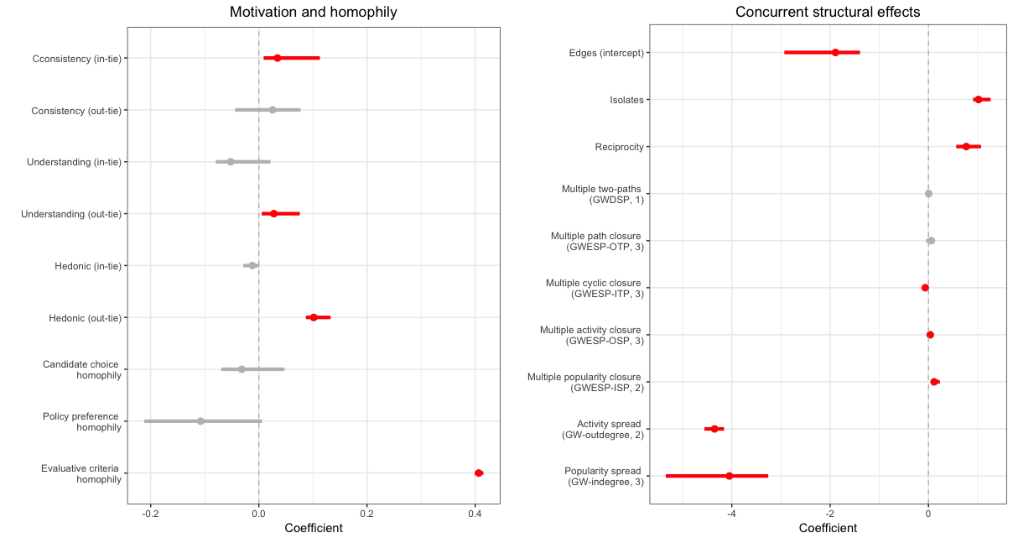

**Panel B: Control Variables**

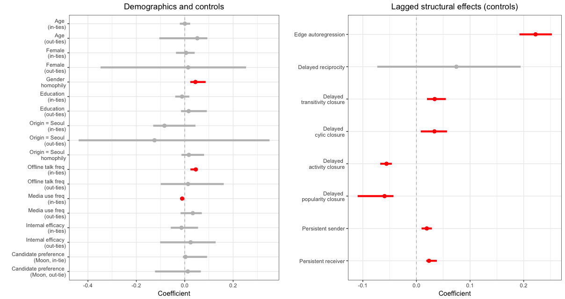

*Figure 1*. Parameter estimates and 95% confidence intervals from the final model. Significant model terms are denoted in red.

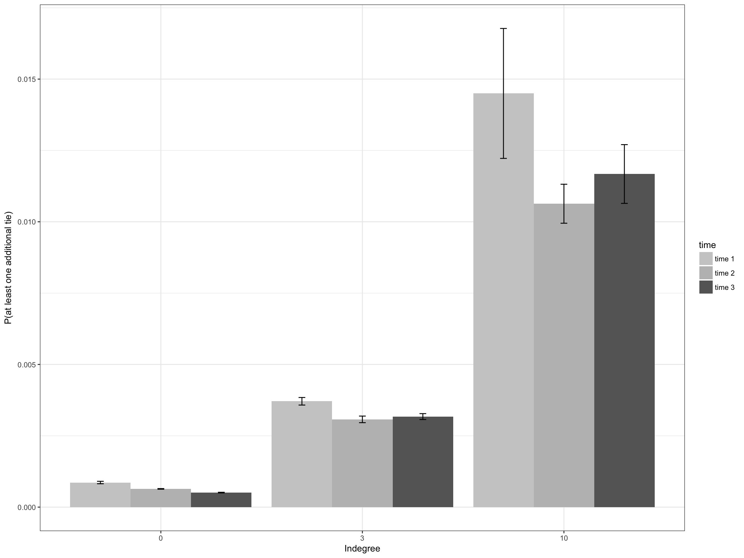

*Figure 2*. Mean predicted probabilities of *receiving* at least one additional tie (i.e., message being selected by others) as a function of existing incoming ties at 10% (= zero), 50% (= three), and 90% (= ten existing ties) percentile of the in-degree distribution. For each receiver node, we derived the mean edge probabilities of all other nodes (excluding any nodes that are already connected) sending a tie to the target node conditional on the rest of the network and on the model specification.

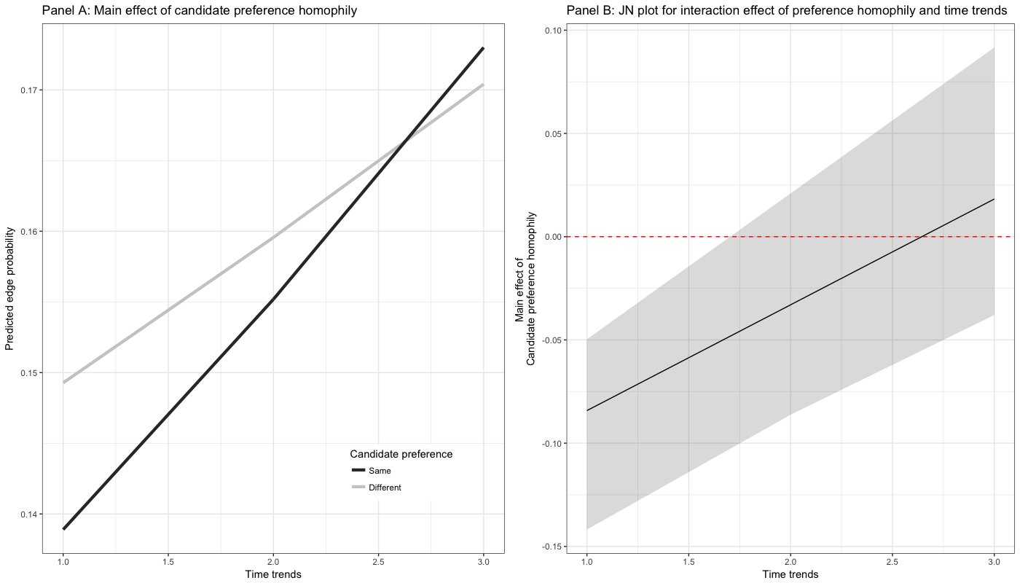

*Figure 3*. Interaction effects between time trends and candidate preference homophily. Panel A depicts conditional main effects of candidate preference homophily at each time point, and Panel B depicts Johnson-Neyman regions of significance as a function of time.

1. Compared to the general population, demographic profiles of our final samples were slightly biased toward younger (sample median age = 35; population = 38) male (sample = 51.9%; population = 49.67%), reflecting the general tendency of those who are active online. Yet because we are taking inferential network-analytic approach, the representativeness is not a major concern here as opposed to the case of traditional survey. In addition, our sample had enough variability in all of the key covariates (especially for candidate preference), making less likely that our results are biased by the peculiarity of our data.
2. We also estimated models with daily slices (*t* = 26) and found largely the same results with minor discrepancies in estimated coefficients and significance level. Combined with multiple imputation results, our robustness check suggest that our results and conclusions are reasonably robust against potential methodological issues.
3. We assume participants’ characteristics (such as their candidate preferences) may drive the creation of network ties but not the other way around, provided that such characteristics were rather stable across survey waves.
4. Candidate choices (W1: *M* = .60, *SD* = .49; W2: *M* = .66, *SD* = .47; W3: *M* = .61, *SD* = .48) were tapped using a dichotomous measure, where “1” denotes supporting liberal candidate (Moon Jae-in) vs. “0” denotes supporting conservative candidate (Park Geun-hye).
5. Policy preferences were measured three times across panel surveys using four-item measures, based on a 7-point scale from “not at all agree” (1) to “very much agree” (7).
6. Although the effect of evaluative criteria similarity was more substantial between those who share the same candidate preference (*b*interaction = .324, [.039, .466]), similarities in evaluative criteria had significant and positive impact on probability of message selection even among individuals with dissimilar candidate preferences.
7. The only exception would be the situation where other (multiple) third actors leave visible traces (such as comments), then a given dyad choose to select each other’s messages and based on such visible traces. Yet this does not necessarily contradict our conclusions.